Project Design Phase-II

Data Flow Diagram & User Stories

|  |  |
| --- | --- |
| Date | 11 October 2022 |
| Team ID | PNT2022TMID41935 |
| Project Name | Project - Smart Waste Management System For  Metropolitan Cities |
| Maximum Marks | 4 Marks |

# Data Flow Diagrams:

A Data Flow Diagram (DFD) is a traditional visual representation of the information flows within a system. A neat and clear DFD can depict the right amount of the system requirement graphically. It shows how data enters and leaves the system, what changes the information, and where data is stored.

# Data Flow Diagram (Level 0):

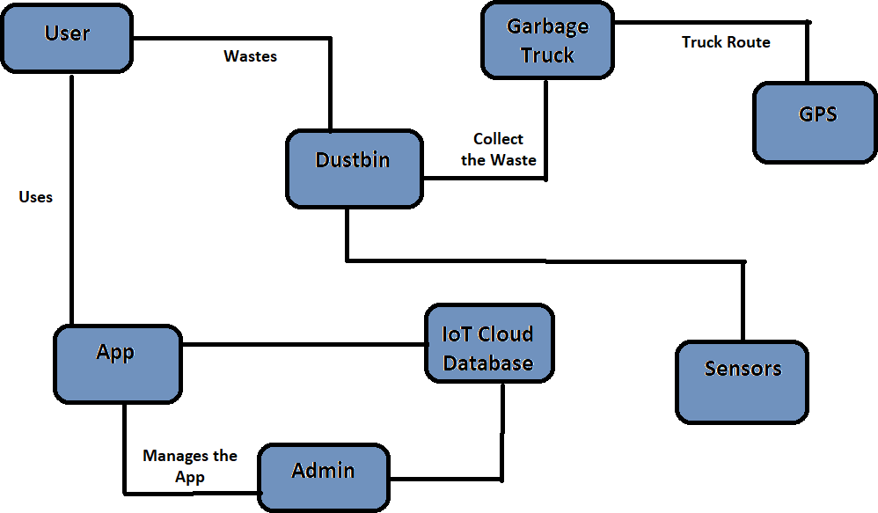

**User Stories**

Use the below template to list all the user stories for the product.

|  |  |  |  |  |  |  |
| --- | --- | --- | --- | --- | --- | --- |
| **User Type** | **Functional**  **Requirement (Epic)** | **User Story Number** | **User Story / Task** | **Acceptance criteria** | **Priority** | **Release** |
| Admin | Login (App/Web Server) | USN-1 | Admin gives User details for every Workers and manage them and manage garbage level when it full. | I can manage Web account/dashboard | High | Sprint-1 |
| Customer | Login | USN-2 | Customer where login to the App and can see the garbage level and put the wastes. | I can see the App and Put the Wastes | High | Sprint-2 |
| Truck Driver | Worker | USN-3 | As a Truck driver can pick the Wastes from the Garbage at a correct time when it full. | I can Collect the Wastes | High | Sprint-3 |
| Co-Admin | Worker | USN-4 | As Co-Admin gets the notification when the  garbage is damage or full and can show city people as Wastes usage. | I can show the Usage of People’s Wastes | Medium | Sprint-2 |
| Customer Care | Worker | USN-5 | Customer care where handles the Customers questions and Problems facing from the Smart bins and gives some instruction. | I can help the customer’s facing problems | Medium | Sprint-2 |